**Submission Guidelines**

Provide the following:

* **Deliverable for Task 1:** Take a screenshot of all the GPOs created for this homework assignment. To find these, launch the Group Policy Management tool, select **Group Policy Objects**, and take a screenshot of the GPOs you've created.
  + 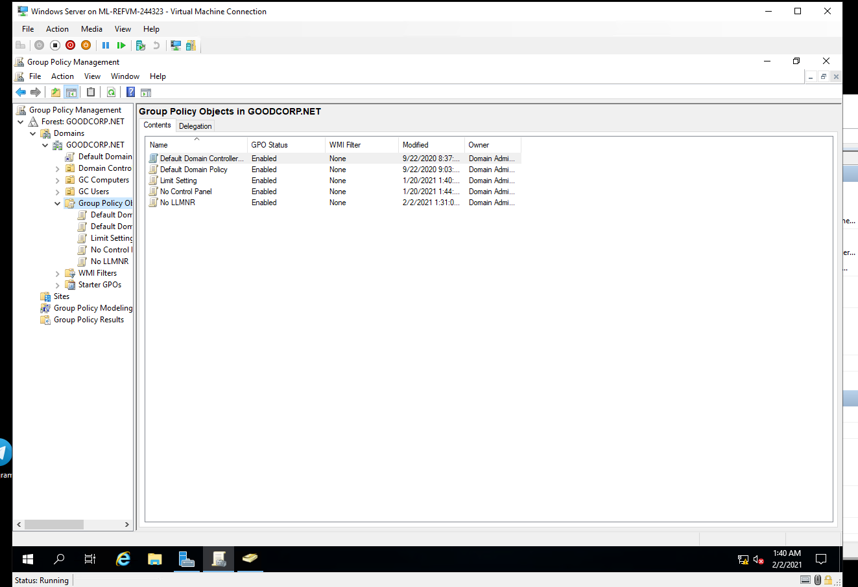
  + 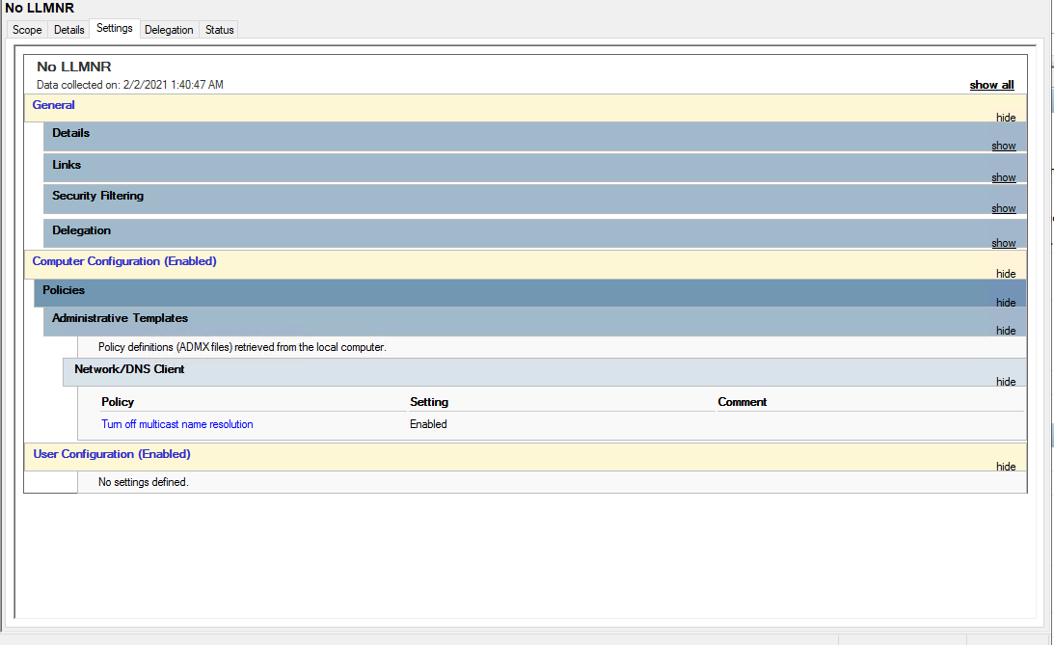
  + 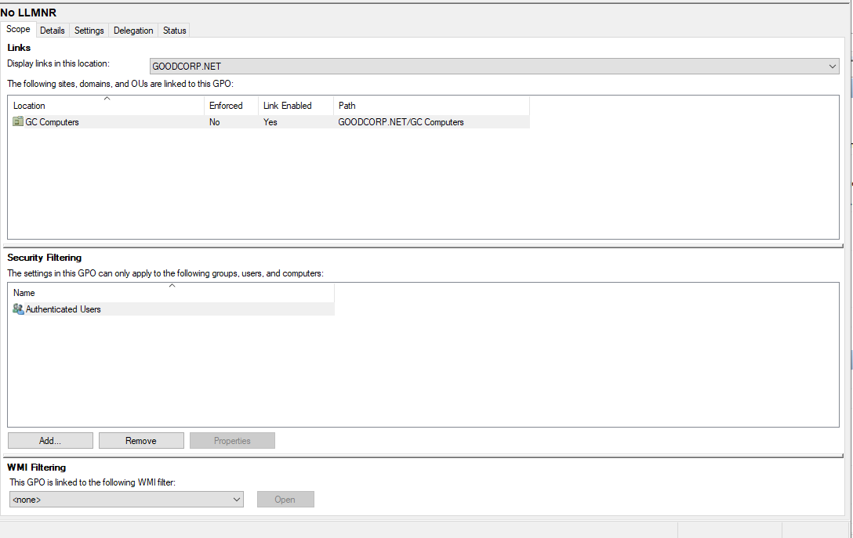
* **Deliverable for Task 2:** Submit a screenshot of the different Account Lockout policies in Group Policy Management Editor. It should show the three values you set under the Policy and Policy Setting columns.
  + 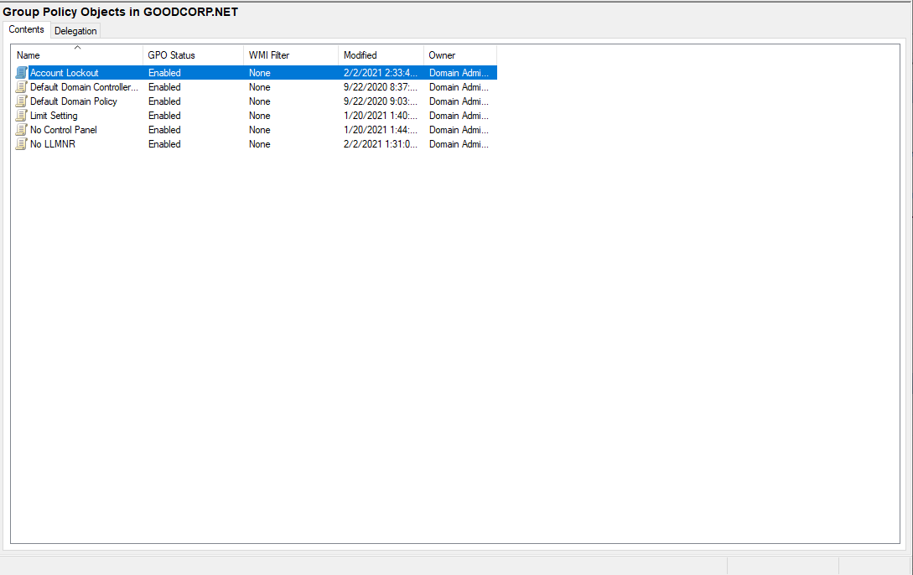
  + 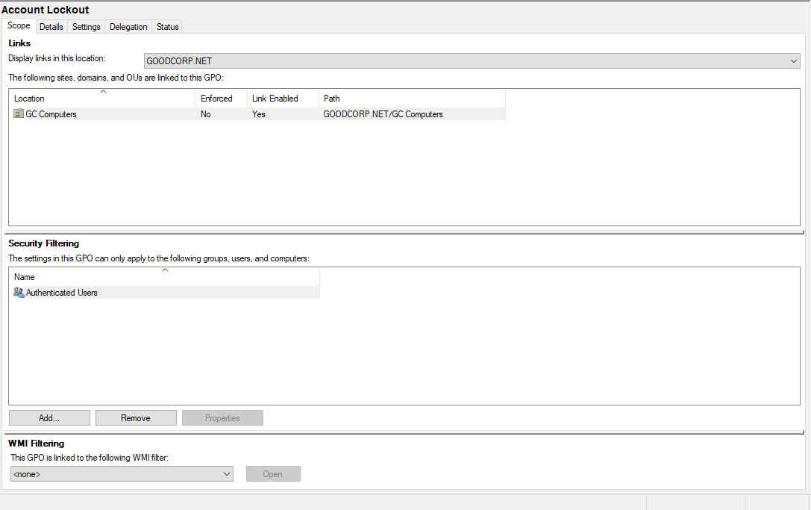
  + 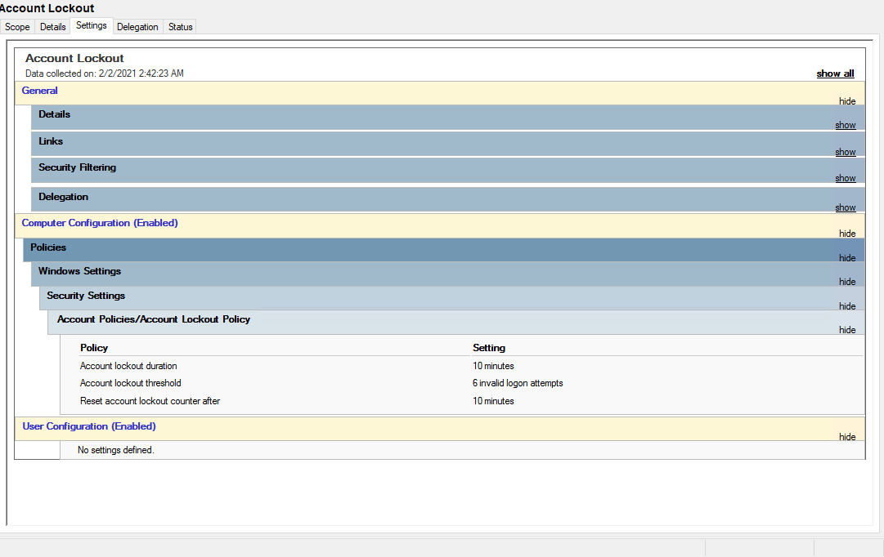
* **Deliverable for Task 3:** Submit a screenshot of the different Windows PowerShell policies within the Group Policy Management Editor. Four of these should be enabled.
  + 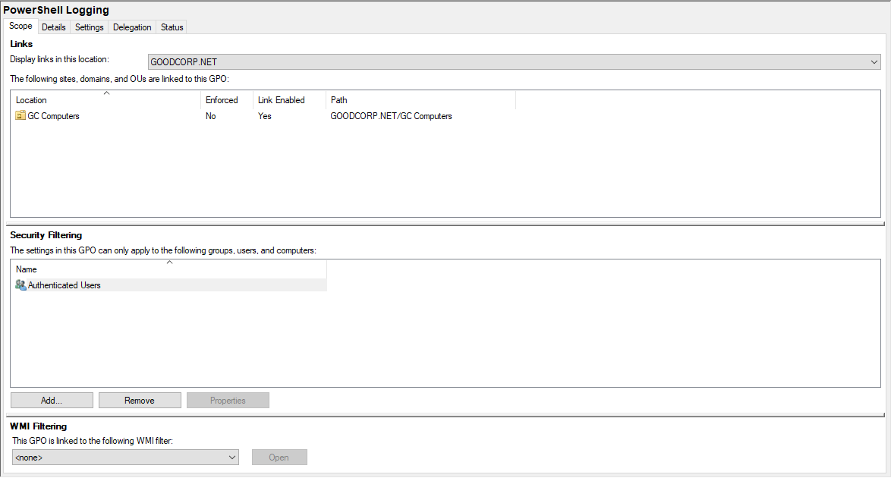
  + 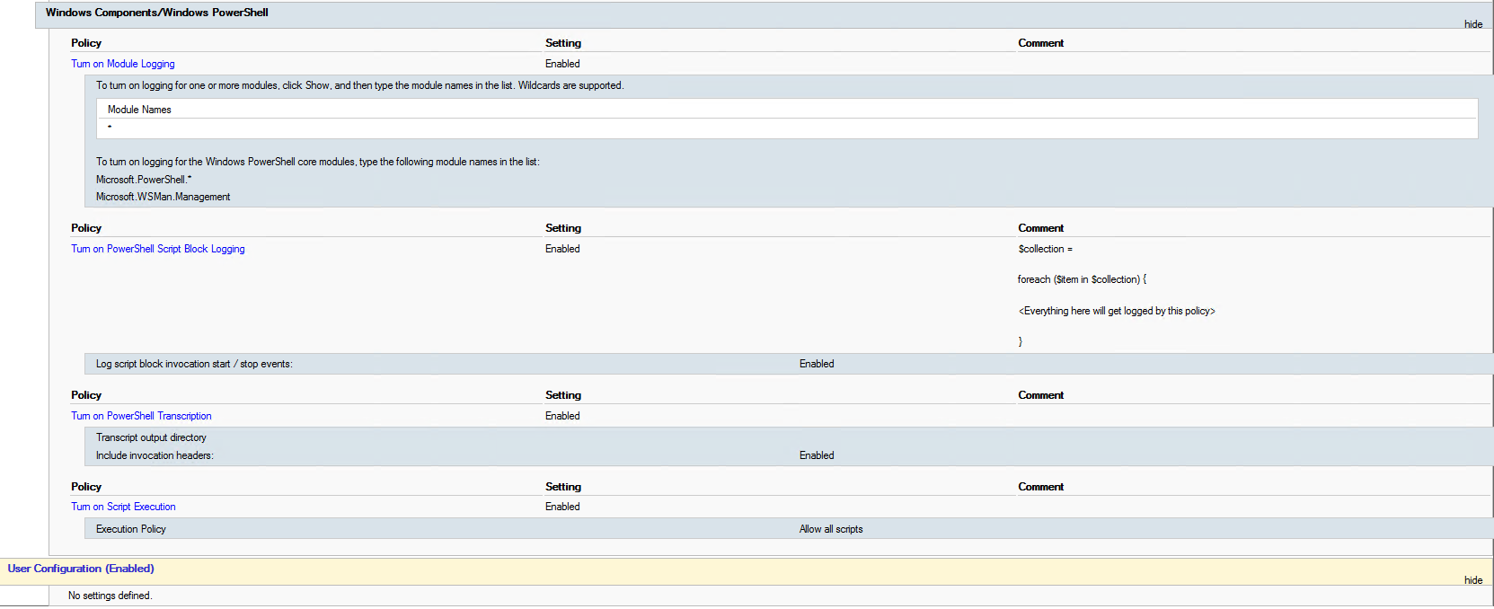
  + 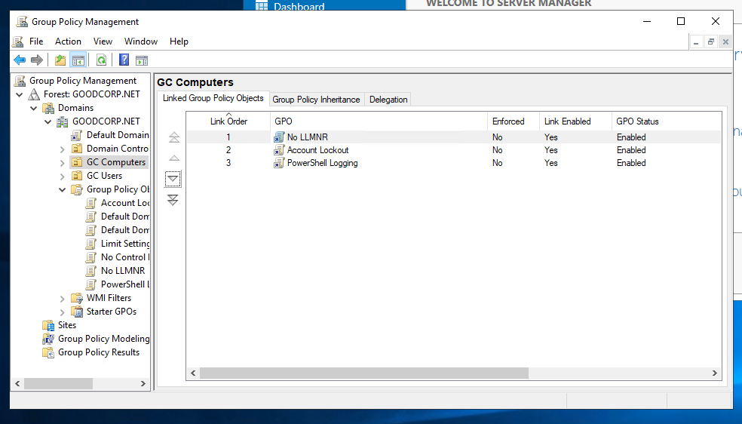
* **Deliverable for Task 4:** Submit a copy of your enum_acls.ps1 script.
  + 